|  |
| --- |
| OTH Regensburg |
| Spatial Databases |
| Project Report |

|  |
| --- |
| Birgit Huber, Florian Fritz, Florian Fußeder  2.1.2017 |

Inhaltsverzeichnis

Project Summary 2

Decisions 2

Questions for the User 2

Processing the Data 0

Neighborhood-Tabulation-Areas 0

School Points 0

Colleges and Universities 0

Parking lot areas 0

Population 0

Complaint data 0

Rental Data 1

Subways 2

Soccer fields 2

Play areas 2

Parks 2

Restaurants 3

# Project Summary

The goal of the project was to create a web application that helps a user to find a suitable region for accommodation in a city. By answering a series of questions about the preferences and living circumstances we aim to suggest a ranked list of the zones of a city.

Furthermore, the user should be able to enter some main locations. With the given data we are able to calculate a time- and cost-efficient route.

After some research we choose the city “New York” and discussed the which datasets we might use. Using the datasets, we defined our questions for the user and started with processing the data for an easy integration in our project. Afterwards we were able to start with the development of the final webpage.

# Decisions

We started off by considering 9 which we thought might be interesting and might have good datasets. Each member of the team had a closer look at the city and its availed datasets as following.

* Birgit: San Francisco, Beijing, London
* Florian Fr: Berlin, New York, Tokyo
* Florian Fu: Munich, Seoul, Singapore

After a week we had a discussion about the results and choose New York. One of the main reasons for that is that the United States has a lot of open geo datasets because of an open data initiative[1] . New York has its own website with data[2] which we used to get the data for our project. New York is also by default divided into 5 Zones with total area of approx. 790 km² and 194 Neighborhood-Tabulation-Areas (NTA) with an average size of four km² which perfectly suited the needs of our project. With the questions, we wanted to ask the user, we chose to use the following dataset.

* Parks
* Play areas
* Restaurants
* Soccer Fields
* School Points
* Parking lots
* Rental Prices
* Colleges and University’s
* Population
* Complaint Data
* Subways

# 

# Questions for the User

Resulting out of our chosen datasets we picked the following questions to determine a suitable NTA for the user.

* Age range
* Has Children
* Is a student
* Owns a car
* Has a dog
* Does outdoor sports
* Uses subway
* Likes nature
* Prefers vibrant or quiet areas
* Importance of low rental prices
* Prefer to live central
* Favors specific zones

# Processing the Data

Each Dataset was processed individuality. The result of each dataset a database view containing a rating value between zero to one for each region in terms of the data. For example, the area with the least parking lot area scores the lowest rating, the area with the most scores one. This allows us to easily weight the different ratings in the web application as they are now all in the same range.

## Neighborhood-Tabulation-Areas

As mentioned we chose the NTA areas as foundation of our ratings and zones which we want to suggest to our user. The NTA could easily be imported from the exiting shapefiles[3]. The Shapefile contained a NTA code, the NTA name, the geometry and some other metadata. Nothing had to be processed in this table.

## School Points

The School point data[4] was imported as shapefile containing locations as geometry based on the official address. It also includes some basic school information such as Name, Address, Principal, and Principal’s contact information.

The rating of how good a NTA is, in terms of School Points, was determined by the amount of points within the area. This was done by using basic postgis queries[5] ,including ST_AREA and ST_CONTAINS. As final step a normalized view which only contained NTA code and the rating[6].

## Colleges and Universities

Like the School points table, the data that we used for the colleges also where easy to import because of the shapefile[7] format, and included some metadata like the name and the street name and the geometry.

Again, the rating of areas containing a college or a university is higher than regions that do not. After viewing the data in the web application we came to the conclusion that because of the low number and the bulked locations only a few areas would have a good rating. So we decided it would be better for our rating to use ST_DWITHIN and add a distance of 200 for our rating view[8].

## Parking lot areas

The parking lot data also already included the geometry of the area[9]. So we just had to prepare the data for our rating.

In this case we have two polygon geometries and we want the area of all parking lots so we used ST_INTERSECTS. To get an accurate rating that is not biased towards bigger NTA areas, we calculated the m² of parking space per m² in the area[10].

## Population

The population data consisted of a simple csv-file[11] that consisted the data from 2000 and the data of the year 2010.

After removing the data from 2000 we had usable data that only had to be match by NTA-code[12]. To get a more accurate rating of how crowded the regions are, we calculated the population per m² in the area.

## Complaint data

This dataset[13] includes crimes that were reported to the Police for the first three quarters of 2016. The csv-file had the latitude and longitude data some metadata which we cut out to speed up the database queries.

To get a rating of how many crimes have been reported to the police we had to create a point geometry out of the longitude and longitude by using ST_MAKEPOINT. After that we used ST_CONTAINS to determine the count of crimes within an area[14].

## Rental Data

To determine a approx. rating of the buying/rental data of the specific areas we used the condominium provided by the NYC department of finances[15].

The datasets consist out of complex Excel Worksheets with much data that where not needed for our project and had to be converted into simple csv-format. Because the data had no spatial data nor a reliable source to match the csv-entries to a specific NTA-area but the address of the building, we decided to use a geocoding[16] API. In our case we used the Python Mapbox API to write a simple script[17] consisting of reading the csv-file, sending the address, receiving the latitude longitude and writing this data into the csv-format. After reviewing the locations of the points that we had produced with the locations from the Mapbox geocoder we discovered that a lot of the produced points where located all over the world. After checking the points, we discovered that approx. 2450 out of the total 23080 entries are clearly out of the boundaries of New York.

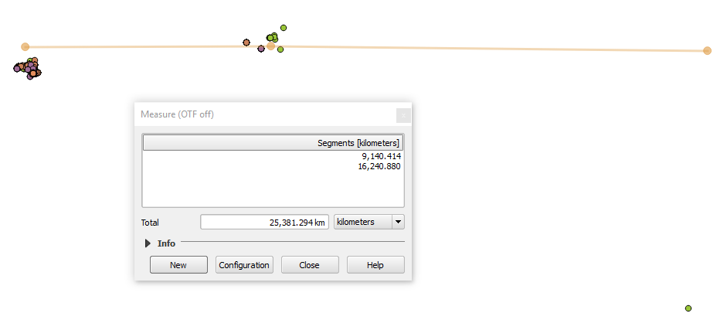

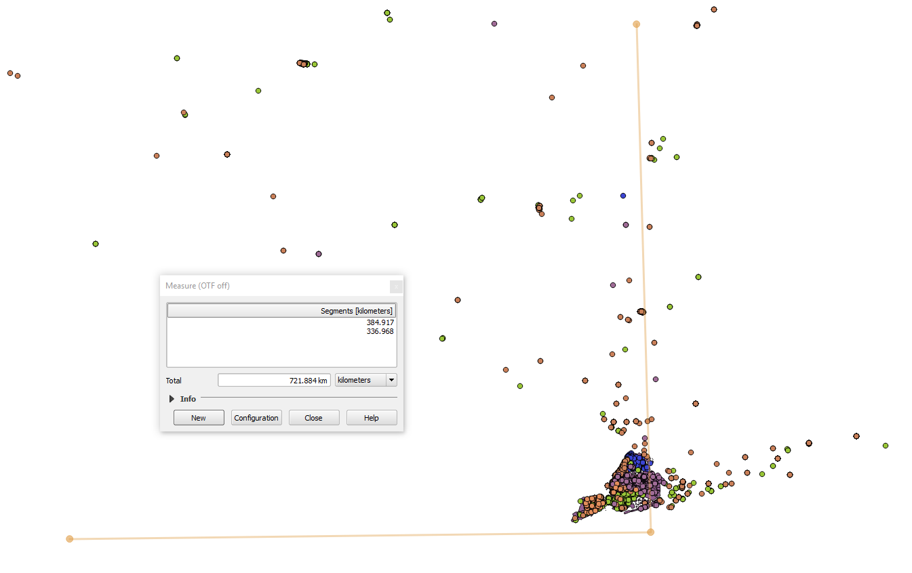

Because we decided that we did not want to use such unreliable data, we wrote another Python script[18], but this time we did chose the geocoder API from Google Maps. After checking the locations of the points we created out of the Google latitude and longitude and checking this data in the same way as the Mapbox locations we discovered that only four points where not located in New York. So we did use Google locations to determine average market value per square feet which should give a basic overview of the price range of a NTA.

## Subways

The data for the subway was imported as a shapefile[19] which includes the name of a certain subway station, it’s geometry as a point and other meta data.

Then a new table was created containing the distance to the next subway entrance for each NTA zone. This was done by using the postgis ST_DISTANCE method we have learned during our lectures. At last there was added a rating to the table which represents the normalised distance for each neighbourhood, with ranges from one if there is a subway entrance in the zone to 0 for the zone furthest away from any subway connection[20]. Resulting there was a table containing only the id of the NTA and the rating[21] for further processing.

## Soccer fields

The Soccer field data set was imported as a shapefile[22] into the postgis database program.

The data relation consists of the geometry of the field as well as of its id and other meta data. Similar to the previously described data processing of the subway, for each NTA area was calculated the distance to the closest football field[23], as there are not that many field in New York. So in the end there was a relation with the id of the NTA and its normalised distance to the next soccer field[24].

## Play areas

The data for the play areas were also imported as a shapefile from the official geo data website of New York City[25]. It included the geometry of the park and other meta data which we were of no use for us.

First the number of playgrounds in a certain NTA region was calculated by joining the NTA with the playareas table on whether a certain play ground is in that NTA zone using ST_INTERSECTS. As a further step the same procedure was repeated to find play areas near the zone using ST_DISTANCE with a distance of 500m, as it seemed reasonable to also considerer those parks. Afterwards those two parts were put together on rating the parks in the NTA area thrice the weight of the ones in the adjacent region[26]. Finally, the rating was calculated by considering the total amount of playgrounds in and nearby the zone as well as the zone’s area[27]. Those steps were all performed successively as of a lack of performance of the database.

## Parks

The data for the parks and recreational areas[28] of New York City was also downloaded as a shapefile and imported into the postgis database program.

The table consists of several columns including the geometry, location, name and other attributes. Firstly, the total area of all parks in a particular NTA zone was calculated by joining the previously imported park table with the NTA one. Therefor the postgis functions ST_AREA, ST_INTERSECTS and ST_INTERSCETION which were presented during our lectures were used. As in this case not only the parks in a certain NTA region, but also the ones close by seem to be relevant, a buffer of 500 m was added around the zone to also determine the possible adjacent recreational areas. Afterwards the total area of all parks counting for a certain NTA region were summed up and divided through the area of the NTA zone to also take that under consideration. For this calculations the database functions ST_BUFFER, ST_SETSRID and ST_DIFFERENCE were used[29]. In the end this number was normalised as the rating with a range from zero to one regarding how much park area exists in this NTA neighbourhood[30]. These procedures were all executed in small steps as of the performance of the database program.

## Restaurants

To get the data for the restaurants a table[31] was downloaded as a CSV file from the official governmental geo data website of New York City and imported as a text file into the database program. That table included an address with a street name and zip code of a restaurant and several other meta data.

As for further processing a geometry data entry was needed to determine the exact location of the restaurant a second data set[32] which matched addresses with a geometry was imported. So, for further processing of that data, irrelevant information like building numbers and other meta data not needed were removed that it contains only valid data with a geometry object and every data only once. After eliminating multiple entries to one restaurant in the restaurant table the two relations were join together using the address with street and zip code. However, this only worked in about half of the cases and the rest could not be matched as of differences in the street name as sometimes there were additionally building numbers in the name or abbreviations were used. As there did not seem to be a better solution the Google Geocoding API was used. For that the not matched restaurants were extracted into another table and exported as text files.

A Java program[33] was developed to read the text files, send for each entry a request to the API which returns the latitude and longitude of the address and save the results in another file. An issue of the API was that the necessity of using a key for the request and the validation of the key which was at about 2500 requests. To avoid this more keys could be requested from the Google API site for other projects. With that solution only about three percentage of the restaurants could not be matched to a location and have to be omitted for further processing.

Afterwards the file with the geo coded data was imported and added to the table with the other restaurants. Finally, the NTA zone’s table was joined with the restaurant’s using the ST_INTERSECTS function to get the total number of restaurants for each NTA neighbourhood[34]. Resulting, the id of the NTA zones and the rating of the total number of restaurants in the particular area were used for further processing[35].

1. https://www.data.gov/
2. https://nycopendata.socrata.com/
3. <https://data.cityofnewyork.us/City-Government/Neighborhood-Tabulation-Areas/cpf4-rkhq>
4. <https://data.cityofnewyork.us/Education/School-Point-Locations/jfju-ynrr/data>
5. <https://github.com/FlorianFusseder/SpatialDatabases/blob/master/FuFlo%20Data/TABLES/4.publicSchoolPoints/SchoolData.sql>
6. <https://github.com/FlorianFusseder/SpatialDatabases/blob/master/FuFlo%20Data/TABLES/4.publicSchoolPoints/view.txt>
7. <https://data.cityofnewyork.us/Education/Colleges-and-Universities/4kym-4xw5>
8. <https://github.com/FlorianFusseder/SpatialDatabases/blob/master/FuFlo%20Data/TABLES/2.colleguesAndUniversitys/view.txt>
9. <https://data.cityofnewyork.us/City-Government/Parking-Lot/h7zy-iq3d>
10. <https://github.com/FlorianFusseder/SpatialDatabases/blob/master/FuFlo%20Data/TABLES/3.parkintLot/ParkingData.sql>
11. <https://data.cityofnewyork.us/City-Government/New-York-City-Population-By-Neighborhood-Tabulatio/swpk-hqdp>
12. <https://github.com/FlorianFusseder/SpatialDatabases/blob/master/FuFlo%20Data/TABLES/6.population/populationData.sql>
13. <https://data.cityofnewyork.us/Public-Safety/NYPD-Complaint-Data-Current-YTD/5uac-w243>
14. <https://github.com/FlorianFusseder/SpatialDatabases/blob/master/FuFlo%20Data/TABLES/7.complaint/complaintData.sql>
15. <http://www1.nyc.gov/site/finance/taxes/property-cooperative-and-condominium-comparables.page>
16. Computational process of transforming a postal address to a location (latitude longitude)
17. <https://github.com/FlorianFusseder/SpatialDatabases/tree/master/Geocoder/Geocoder_mapbox>
18. <https://github.com/FlorianFusseder/SpatialDatabases/tree/master/Geocoder/Geocoder_google>
19. <https://data.cityofnewyork.us/Transportation/Subway-Stations/arq3-7z49>
20. <https://github.com/FlorianFusseder/SpatialDatabases/blob/master/data/subway/subway.sql>
21. <https://github.com/FlorianFusseder/SpatialDatabases/blob/master/data/subway/subwaydistance_table.txt>
22. <https://data.cityofnewyork.us/Recreation/Map-of-Soccer-and-Football-Fields/qqsi-vm9f>
23. <https://github.com/FlorianFusseder/SpatialDatabases/blob/master/data/soccerfields/soccerfields.sql>
24. <https://github.com/FlorianFusseder/SpatialDatabases/blob/master/data/soccerfields/soccerfield_data.txt>
25. <https://data.cityofnewyork.us/City-Government/Play-Areas/8fhn-c4v3>
26. <https://github.com/FlorianFusseder/SpatialDatabases/blob/master/data/playgrounds/playgrounds.sql>
27. <https://github.com/FlorianFusseder/SpatialDatabases/blob/master/data/playgrounds/neighbourhood_playground_table2.txt>
28. <https://data.cityofnewyork.us/City-Government/Parks-Properties/rjaj-zgq7>
29. <https://github.com/FlorianFusseder/SpatialDatabases/blob/master/data/parks/park2.sql>
30. <https://github.com/FlorianFusseder/SpatialDatabases/blob/master/data/parks/neighbourhood_parks_table2.txt>
31. <https://data.cityofnewyork.us/Health/DOHMH-New-York-City-Restaurant-Inspection-Results/xx67-kt59>
32. <https://data.cityofnewyork.us/City-Government/NYC-Address-Points/g6pj-hd8k>
33. <https://github.com/FlorianFusseder/SpatialDatabases/blob/master/data/restaurants/geoCoding.java>
34. <https://github.com/FlorianFusseder/SpatialDatabases/blob/master/data/restaurants/restaurants2.sql>
35. <https://github.com/FlorianFusseder/SpatialDatabases/blob/master/data/restaurants/restaurants_table2.txt>